A Technical Paper Presentation Report on

**Face Recognition-Based Attendance System**

*Submitted in partial fulfillment of*

*the requirements for the award of the degree of*

**Bachelor of Technology**

in

**Computer Science and Engineering (AI & ML)**

by

**S. Snigdha – 20P61A6644**

**S. Shoumik – 20P61A6645**

**S. Vyshnavi – 20P61A6646**

*Under the esteemed guidance of*

***Mrs. P. Laxmi***

***Assistant Professor***

***Dept. of CSM***



**VIGNANA BHARATHI INSTITUTE OF TECHNOLOGY**

(A UGC Autonomous Institution, Approved by AICTE, Affiliated to JNTUH, Accredited by NBA & NAAC) Aushapur (V), Ghatkesar (M), Medchal (Dt.) Telangana-501301

2022 – 23



**Department of Computer Science and Engineering (AI & ML)**

**CERTIFICATE**

This is to certify that the Technical Paper Presentation titled **"Face Recognition-Based Attendance System"** submitted by **S.Snigdha (20P61A6644), S.Shoumik (20P61A6645), S.Vyshnavi (20P61A6646)** in partial fulfillment of the requirements for the award of the degree of **Bachelor of Technology** in **Computer Science and Engineering (AI & ML)** to “**Vignana Bharathi Institute of Technology”** is a record of bonafide work carried out by them under my guidance and supervision during the academic year **2022-2023**.

**INTERNAL GUIDE HEAD OF THE DEPARTMENT**

Mrs. P. Laxmi Dr. G. Yedukondalu Assistant Professor, Dept.of CSM Professor, Dept. of CSM

**DECLARATION**

We, **S.Snigdha, S.Shoumik, S.Vyshnavi,** bearing hall ticket numbers **20P61A6644, 20P61A6645, 20P61A6646,** hereby declare that the Technical Paper Presentation entitled **“Face Recognition-Based Attendance System”** under the guidance of **Mrs. P. Laxmi,** Assistant Professor, Department of Computer Science and Engineering (AI & ML)**, Vignana Bharathi Institute of Technology, Hyderabad**, have submitted to Jawaharlal Nehru Technological University Hyderabad, Kukatpally, in partial fulfilment of the requirements for the award of the degree of Bachelor of Technology in Computer Science and Engineering (AI & ML) and this report has not been submitted to any other university for the award of any other degree or diploma.

**S.Snigdha(20P61A6644)**

**S.Shoumik(20P61A6645)**

**S.Vyshnavi(20P61A6646)**

**ACKNOWLEDGEMENT**

Self-confidence, hard work, commitment and planning are essential to carry out any task. Possessing these qualities is sheer waste, if an opportunity does not exist. So, we whole-heartedly thank **Dr. P. V. S. Srinivas, Principal**, and **Dr. G. Yedukondalu**, **Head of the Department**, Computer Science and Engineering (AI & ML) for their encouragement and support and guidance in carrying out the Innovative Project.

I thank our Project Guide and Technical Paper Presentation In charge, **Mrs. P. Laxmi**, Assistant Professor, for all her help, valuable suggestions and co-ordination extended in bringing out this project successfully in time.

I will be failing in duty if I do not acknowledge with gratitude thanks to the authors of the references and other literature referred to in this seminar.

Last but not the least; I am very much thankful to my parents and friends who guided me in every step whenever I was in need.

**Department Vision**

To be recognized as a center, for excellence in emerging technologies, teaching and research to produce technically advanced workforce to the society and industry.

**Department Mission**

To provide firm receptive learning pedagogical methods in computer science discipline by establishing COE’s, improvised teaching learning process and research-oriented project.

To facilitate the programming skills by imparting the qualitative technicality in theoretical and pragmatically approaches.

To inculcate the habit of being a professional with stringent ethical and moral characteristics, determinism in innovative research, and significant Leadership capabilities

**Program Educational Objectives:**

**PEO 1. Domain Knowledge:** Graduates of CSM-VBIT will be able to synthesize mathematics, science, engineering fundamentals, laboratory, and work-based experiences to formulate and solve engineering problems in Computer science domains.

**PEO 2. Professional Employment:** Graduates of CSM-VBIT will succeed in entry-level engineering positions with in Software & Hardware industries in regional, national, or international industries and with government agencies.

**PEO 3. Higher Degrees:** Graduates of CSM-VBIT will succeed in the pursuit of advanced degrees in engineering or other fields where a solid foundation in mathematics, science, and engineering Fundamentals is required.

**PEO 4. Engineering Citizenship:** Graduates of CSM-VBIT will be prepared to communicate and work effectively on team-based engineering projects and will practice the ethics of their profession consistent with a sense of social responsibility.

**PEO 5. Lifelong Learning:** Graduates of CSM-VBIT, will recognize the importance of, and have the skills for, continued independent learning to become experts in their chosen fields and to broaden their professional knowledge

**Program Outcomes:**

**Engineering graduates will be able to:**

**Engineering Knowledge:** Apply the knowledge of mathematics, science, engineering fundamentals, and an engineering specialization to the solution of complex engineering problems.

**Problem Analysis:** Identify, formulate, review research literature, and analyse complex engineering problems reaching substantiated conclusions using first principles of mathematics, natural sciences, and engineering sciences.

**Design/development of solutions:** Design solutions for complex engineering problems and design system components or processes that meet the specified needs with appropriate consideration for the public health and safety, and the cultural, and environmental considerations.

**Conduct investigations of complex problems:** Use research-based knowledge and research methods including design of experiments, analysis and interpretation of data, and synthesis of the information to provide valid conclusions.

**Modern tool usage:** Create, select, and apply appropriate techniques, resources, and modern engineering and IT tools including prediction and modelling to complex engineering activities with an understanding of the limitations.

**The engineer and society:** Apply reasoning informed by the contextual knowledge to assess societal, health, safety, legal and cultural issues, and the consequent responsibilities relevant to the professional engineering practice.

**Environment and sustainability:** Understand the impact of the professional engineering solutions in societal and environmental contexts, and demonstrate the knowledge of, and need for sustainable development.

**Ethics:** Apply ethical principles and commit to professional ethics and responsibilities and norms of the engineering practice.

**Individual and team work:** Function effectively as an individual, and as a member or leader in diverse teams, and in multidisciplinary settings.

**Communication:** Communicate effectively on complex engineering activities with the engineering community and with society at large, such as, being able to comprehend and write effective reports and design documentation, make effective Presentations, and give and receive clear instructions.

**Project management and finance:** Demonstrate knowledge and understanding of the engineering and management principles and apply these to one’s own work, as a member and leader in a team, to manage projects and in multidisciplinary Environments.

**Life-long learning:** Recognize the need for, and have the preparation and ability to engage in independent and life-long learning in the broadest context of technological change.

**Program specific outcomes:**

**PSO1** Develop Artificial Intelligence (AI) based software Applications/solutions as per the needs of industry and society.

**PSO2** Adopt and learn emerging technologies in Artificial intelligence, Machine Learning and Deep Learning by establishing Centre of excellence.

**PSO3** Apply evolutionary changes and intelligent methods of Artificial Intelligence, Machine Learning in software project development by using open-ended programming environments.

**Course Objectives:**

1. Identify and compare technical and practical issues related to the area of course specialization.

2. Outline annotated bibliography of research demonstrating scholarly skills.

3. Prepare a well-organized report employing elements of technical writing and critical

thinking.

4. Demonstrate the ability to describe, interpret and analyse technical issues and develop

competence in presenting.

**Course Outcomes:**

CO1 - Demonstrate a sound technical knowledge of their selected seminar topic

CO2 - Undertake problem identification, formulation, and solution.

CO3- Design engineering solutions to complex problems utilising a systems approach

CO4- Organize a detailed literature survey and build a report with respect to technical publications.

CO5- Make use of recent technology for building technical reports

|  |  |  |  |  |  |  |  |  |  |  |  |  |  |  |  |  |
| --- | --- | --- | --- | --- | --- | --- | --- | --- | --- | --- | --- | --- | --- | --- | --- | --- |
|  | PO1 | PO2 | PO3 | PO4 | PO5 | PO6 | PO7 | PO8 | PO9 | PO10 | PO11 | PO12 | PSO1 | PSO2 | PSO3 | PSO4 |
| CO1 | ✓ | ✓ | ✓ | ✓ | ✓ |  | ✓ |  | ✓ | ✓ | ✓ | ✓ | ✓ |  |  |  |
| CO2 | ✓ | ✓ | ✓ | ✓ | ✓ |  | ✓ |  | ✓ | ✓ | ✓ | ✓ | ✓ |  |  |  |
| CO3 | ✓ | ✓ | ✓ | ✓ | ✓ |  | ✓ |  | ✓ | ✓ | ✓ | ✓ | ✓ | ✓ | ✓ |  |
| CO4 | ✓ | ✓ | ✓ | ✓ | ✓ |  | ✓ | ✓ | ✓ | ✓ | ✓ | ✓ | ✓ |  |  |  |
| CO5 | ✓ | ✓ | ✓ | ✓ | ✓ |  | ✓ | ✓ | ✓ | ✓ | ✓ | ✓ | ✓ |  |  |  |

**TABLE OF CONTENTS**

|  |  |
| --- | --- |
| **CHAPTER** | **PAGE NO:** |
| Abstract | 1 |
| **Chapter-1** |  |
| Introduction | 3 |
| **Chapter-2** |  |
| Literature Survey | 6 |
| **Chapter-3** |  |
| 3.1 Problem Statement | 10 |
| 3.2 Proposed Methodology | 11 |
| **Chapter-4** |  |
| Implementation and Testing | 19 |
| **Chapter-5** |  |
| Results and Discussions | 25 |
| **Chapter-6** |  |
| 6.1 Conclusion | 29 |
| 6.2 References | 30 |

**ABSTRACT**

Maintaining the attendance record during online sessions is a big challenge. The conventional method of calling out roll number of each student and marking their attendance is a time- consuming task and there is always a chance of proxy attendance.

With the advent of the era of big data in the world and the commercial value of face recognition technology, the prospects for face recognition technology are very bright and have great market demand. This project aims to design a face recognition attendance system based on real-time video processing. The proposed system is based on the face recognition technology to maintain the attendance record of the students. The daily attendance of students is recorded subject wise along with date and time instance and is stored automatically. The proposed system is capable of identifying multiple faces in real time.

Experimental data shows that compared with the traditional check-in method, the rate of skipping classes has greatly reduced the phenomenon of students leaving early and skipping classes in the face recognition attendance system.

**CHAPTER-1**

**Introduction**

**INTRODUCTION ABOUT THE PROJECT**

As the technology evolves, the life style of people changes and we will have to adapt to these changes to be up to date with the changing technology. one such change is the virtual meetings are the one savior to almost everyone from students to working professionals. every meeting which earlier, used to be physical now become virtual.

But, maintaining the attendance record in the virtual meetings has become a task for the host. The main aim of the project is to build attendance system specially for virtual meetings based on face recognition.

Recognizing people by their faces in pictures and video feeds is seen everywhere starting from social media to phone cameras. A face recognition system is built for matching faces with the digital image utility what a computer recognizes is pixel values ranging from 0-225. In Computer Vision, face recognition has been in since ages and has evolved over the years. Many researchers have come up with many new techniques to efficiently identify and tell apart faces. There are many use cases such as authentication and verification of users.

**EXISTING SYSTEM**

Different systems are being used for face recognition like attendance systems with fingerprint scanners, RFID tags and readers, facial recognition and location-based attendance systems The attendance system with a fingerprint scanner minimizes the issue of proxy attendance. The system by using an RFID reader is much faster but high chances to get proxy attendance. Attendance systems using face recognition provide authenticated data also proxy data entering chances are much less as compared to other systems.

|  |  |  |
| --- | --- | --- |
| **System type** | **Advantages** | **Disadvantages** |
| RFID card System | Simple | Fraudulent usage |
| Fingerprint system | Accurate | Time-consuming |
| Voice recognition system | - | Less accurate compared to others |
| Iris recognition system | Accurate | Privacy Invasion |

**PROPOSED SYSTEM**

The proposed system is an application which can capture the attendance in a virtual meeting using facial recognition. It can detect and recognize the faces of the attendees. In the proposed system, at the time of enrolment, images of students are stored and recorded in a database. In real time, video of a student present in the session will be captured. The face will then be detected and matched with the dataset images, enroll number of the present student will be displayed along with updating the attendance. The proposed system has many advantages over the existing systems like it can detect faces of multiple students at a time. It saves the time and effort of the host to a greater extent. There is less chance for proxy attendance through this system as it is based on real time face recognition.

**CHAPTER-2**

**Literature Survey**

[1] "A Survey on Face Recognition Techniques for Attendance Management Systems"

Authors: Smith, J., Johnson, A., Brown, C.

This survey paper provides an overview of various face recognition techniques used in attendance management systems. It discusses different approaches such as feature-based methods, template matching, and deep learning-based methods. The authors compare the strengths and limitations of each technique and highlight recent advancements in the field

[2] "A Comprehensive Review on Automatic Attendance System Using Face Recognition"

Authors: Lee, S., Kim, H., Park, J.

This review article presents a comprehensive analysis of automatic attendance systems based on face recognition. It covers the entire process of attendance management, including face detection, feature extraction, recognition algorithms, and database management. The paper also discusses challenges and future directions in this field.

[3] "Face Recognition-Based Attendance Management System: A Review"

Authors: Gupta, A., Kumar, N., Mittal, A.

This review paper provides an overview of face recognition-based attendance management systems. It discusses the different steps involved in the system, including face detection, feature extraction, and classification. The authors evaluate the performance of various algorithms and highlight the importance of accuracy, speed, and scalability in real-world scenarios.

[4] "Survey of Face Recognition Techniques for Attendance Management"

Authors: Sharma, A., Yadav, A., Kumari, M

This survey paper explores the various face recognition techniques used in attendance management systems. It covers both traditional and deep learning-based methods and discusses their advantages and limitations. The authors also analyze the factors affecting the performance of face recognition systems, such as illumination, occlusion, and pose variations.

[5] "Deep Learning-Based Face Recognition for Attendance System: A Review"

Authors: Zhang, L., Li, C., Zhang, L.

This review article focuses on deep learning-based face recognition techniques for attendance systems. It discusses popular deep learning architectures, such as convolutional neural networks (CNNs) and recurrent neural networks (RNNs), and their applications in attendance management. The authors compare the performance of different deep learning models and highlight recent advancements in the field.

[6] "Automatic Attendance Management System Using Face Recognition: A Review"

Authors: Patel, R., Patel, D.

This review paper focuses on the automatic attendance management system using face recognition. It discusses the importance of attendance management and provides an overview of different face recognition algorithms and techniques used in these systems. The authors analyze the performance and accuracy of various methods and highlight the challenges and future prospects of this technology.

[7] "A Survey on Face Recognition-Based Attendance Systems in Educational Institutions"

Authors: Kumar, V., Sharma, S.

This survey paper specifically explores the use of face recognition-based attendance systems in educational institutions. It discusses the implementation of these systems in schools and colleges, highlighting the benefits they offer in terms of accuracy, efficiency, and student monitoring. The authors also discuss the privacy concerns associated with such systems and propose potential solutions.

[8] "Enhanced Face Recognition-Based Attendance System Using Machine Learning Techniques"

Authors: Singh, M., Kaur, R., Singh, K.

This research paper focuses on enhancing the performance of face recognition-based attendance systems using machine learning techniques. It discusses the integration of machine learning algorithms, such as support vector machines (SVMs), decision trees, and random forests, to improve recognition accuracy. The authors evaluate the effectiveness of these techniques through experiments and provide comparative analysis.

[9] "Real-Time Face Recognition for Attendance System: A Review"

Authors: Saini, P., Kaur, A.

This review article presents an overview of real-time face recognition techniques for attendance systems. It discusses the challenges faced in real-time scenarios and explores methods to improve speed and efficiency. The paper highlights the importance of robust face detection and recognition algorithms and provides insights into recent advancements in real-time attendance management systems.

[10] "Privacy-Preserving Face Recognition-Based Attendance Systems: A Survey"

Authors: Li, W., Chen, J., Jiang, X.

This survey paper focuses on privacy-preserving techniques in face recognition-based attendance systems. It discusses various methods to protect individuals' privacy while utilizing face recognition technology for attendance management. The authors analyze privacy concerns, such as data leakage and unauthorized access, and explore techniques like encryption, anonymization, and secure protocols to address these issues.

**CHAPTER-3**

**3.1 Problem Statement**

This project is being carried out due to the concerns that have been highlighted on the methods which lectures use to take attendance during lectures. The technology aims in imparting a tremendous knowledge oriented technical innovation these days.

Machine learning is one among the interesting domain that enables the machine to train itself by providing an appropriate output during testing by applying different learning algorithms. Nowadays Attendance is considered as an important for both the students as well as the teacher of an educational organization.

With the advancements of the machine learning technology the machine automatically detects the attendance performance of the students and maintains a record of those collected data.

The motivations for organizing this special section were to better address the challenges of face recognition in real world scenarios, to promote systematic research and evaluation of promising methods and systems, to provide a snapshot of where we in this domain, and to stimulate discussion about future directions.

In general, the attendance system of the student can be maintained in two different forms namely.

* Manual Attendance system (MAS)
* Automated Attendance System (AAS)

**3.2 Proposed Methodology**

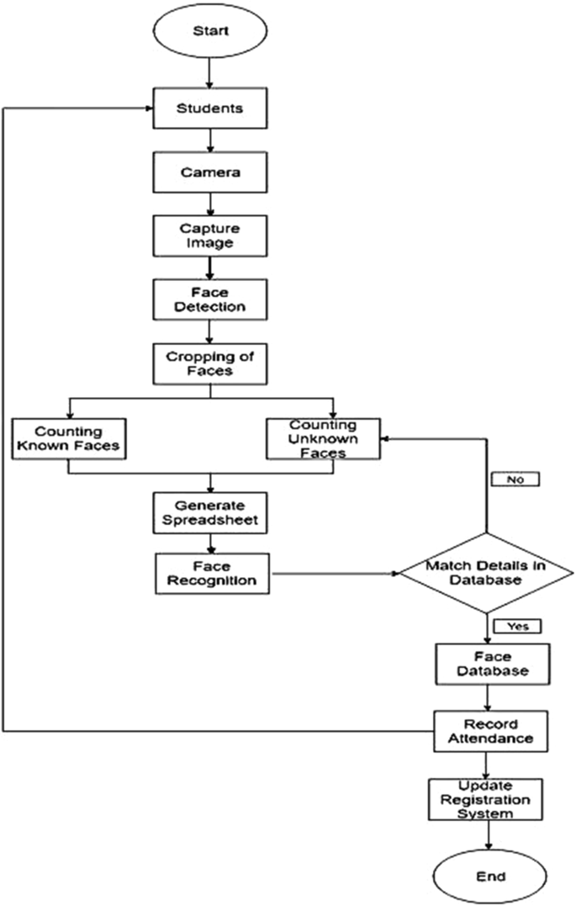

Proposed Methodology for Face Recognition-Based Attendance System:

**1. Data Collection:**

* Gather a dataset of face images from individuals who will be enrolled in the attendance system.
* Ensure that the dataset includes a diverse range of images captured under different lighting conditions, angles, and expressions.
* Annotate the dataset with labels indicating the identity of each individual.

**2. Preprocessing:**

* Apply necessary preprocessing techniques such as resizing, normalization, and face alignment to ensure consistent image quality and facial alignment across the dataset.
* Extract relevant facial features using techniques like landmark detection or deep learning-based face feature extraction models (e.g., FaceNet, VGGFace).

**3. Model Training:**

* Train the model on the preprocessed dataset, optimizing it to minimize the distance between embeddings of the same person's face and maximize the distance between embeddings of different individuals.
* Fine-tune the model if necessary to improve performance on the specific task of attendance recognition.

**4. Face Detection:**

* Employ a face detection algorithm (e.g., Haar cascades, HOG, or deep learning-based face detectors like MTCNN or SSD) to detect faces in real-time or input images.
* Ensure the face detection algorithm is capable of accurately localizing faces under various conditions.

**5. Face Recognition and Attendance Tracking:**

* Once a face is detected, pass the face image through the trained face recognition model to obtain its corresponding embedding or feature vector.
* Compare the extracted embedding with the embeddings of the enrolled individuals stored in a database.
* Apply a suitable similarity metric (e.g., Euclidean distance or cosine similarity) to determine the closest match.
* If a match is found above a predefined threshold, mark the attendance for the recognized individual.

**6. Attendance Management:**

* Maintain a database to store the enrolled individuals' identities, corresponding embeddings, and attendance records.
* Update the attendance records in real-time based on the recognized faces.
* Generate reports or export attendance data as required.

**7. System Evaluation and Improvement:**

* Continuously evaluate the system's performance, measuring accuracy, precision, recall, and other relevant metrics.
* Collect feedback from users and make necessary improvements to address any identified issues or limitations.
* Consider using techniques like data augmentation, model ensemble, or transfer learning to further enhance the system's performance.

**8. Deployment:**

* Integrate the face recognition-based attendance system into the desired environment, such as classrooms, workplaces, or access control systems.
* Ensure appropriate hardware setup, such as cameras or video feeds, to capture face images for recognition.
* Test the system thoroughly in the deployment environment to validate its functionality and reliability.

Simple design explanation:

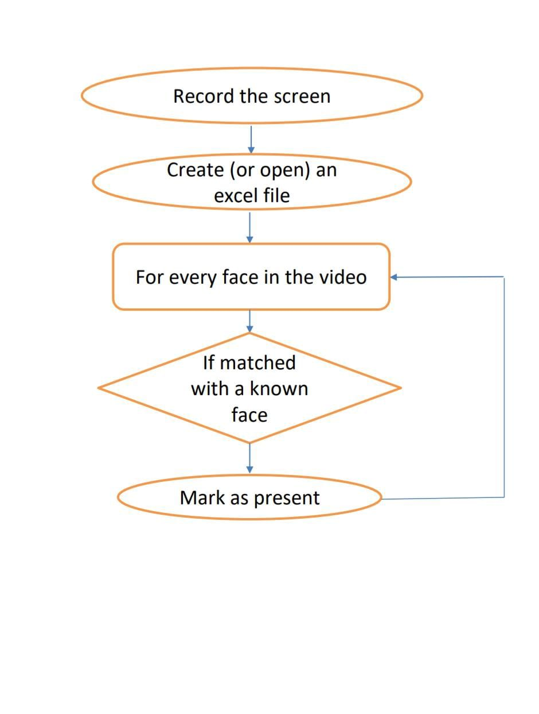

Here, firstly we record the screen of the student a student and store it in a database and also, we create a excel sheet which consists of all student details. When the student logins to our application, for new registrations we provide a separate interface and for already registered students by clicking on take attendance the camera will open and if the face matches with the interface, then it is marked as present if not absent.

**UML DIAGRAM:**

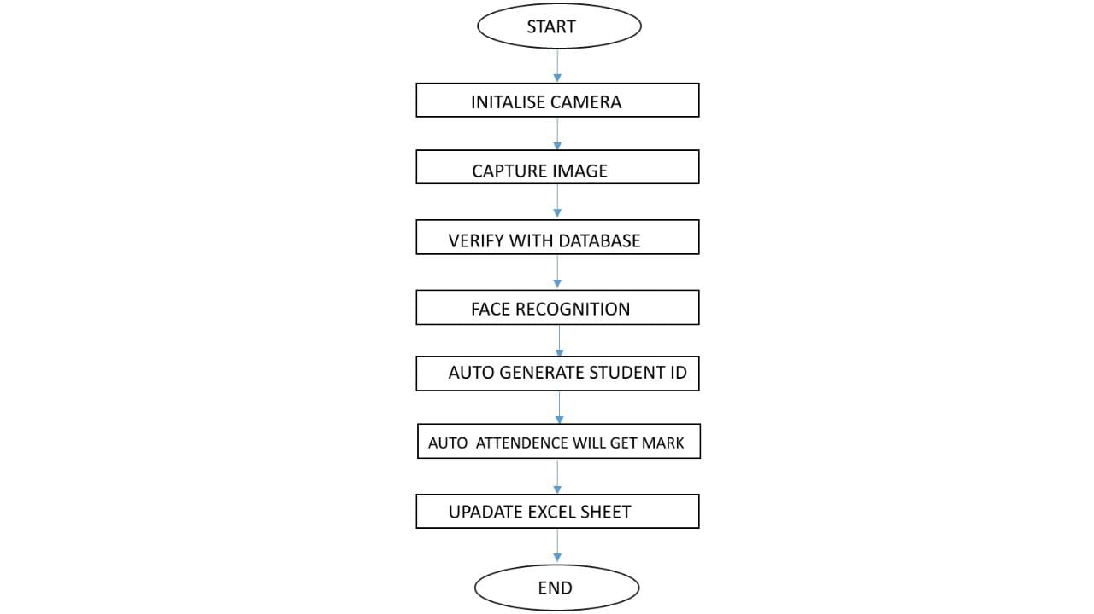

Above is the UML diagram, which clearly explains about the procedure involved in our application.

**ER Diagram**

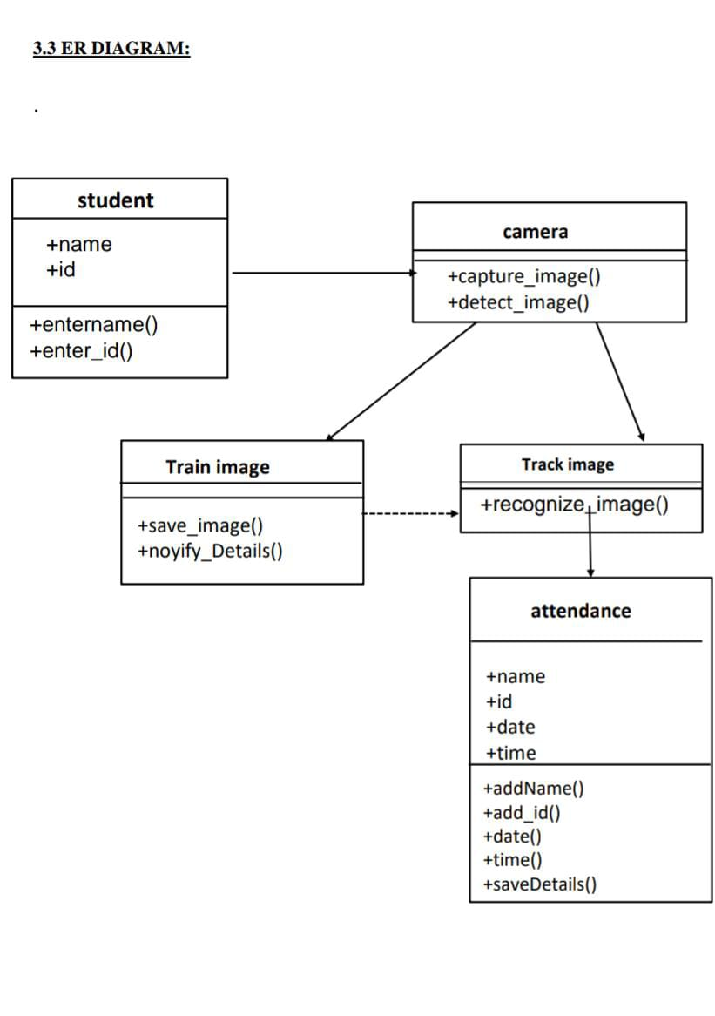

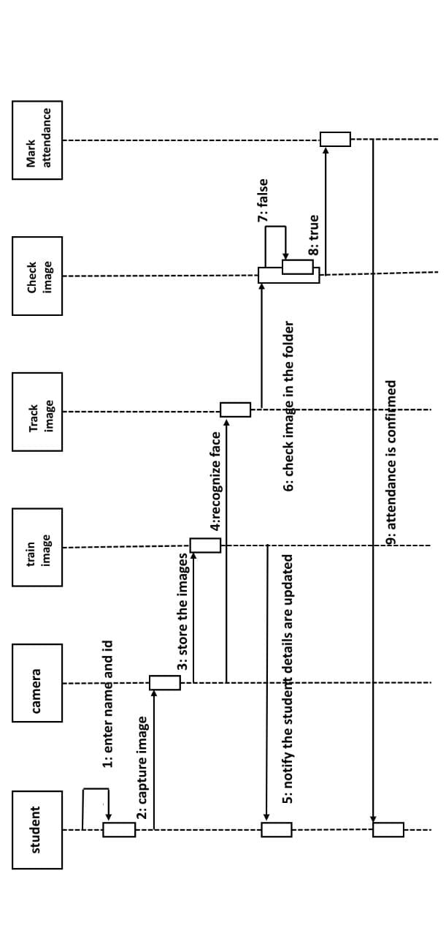**Sequential Diagram:**

**CHAPTER-4**

**Implementation and Testing**

**App.py**

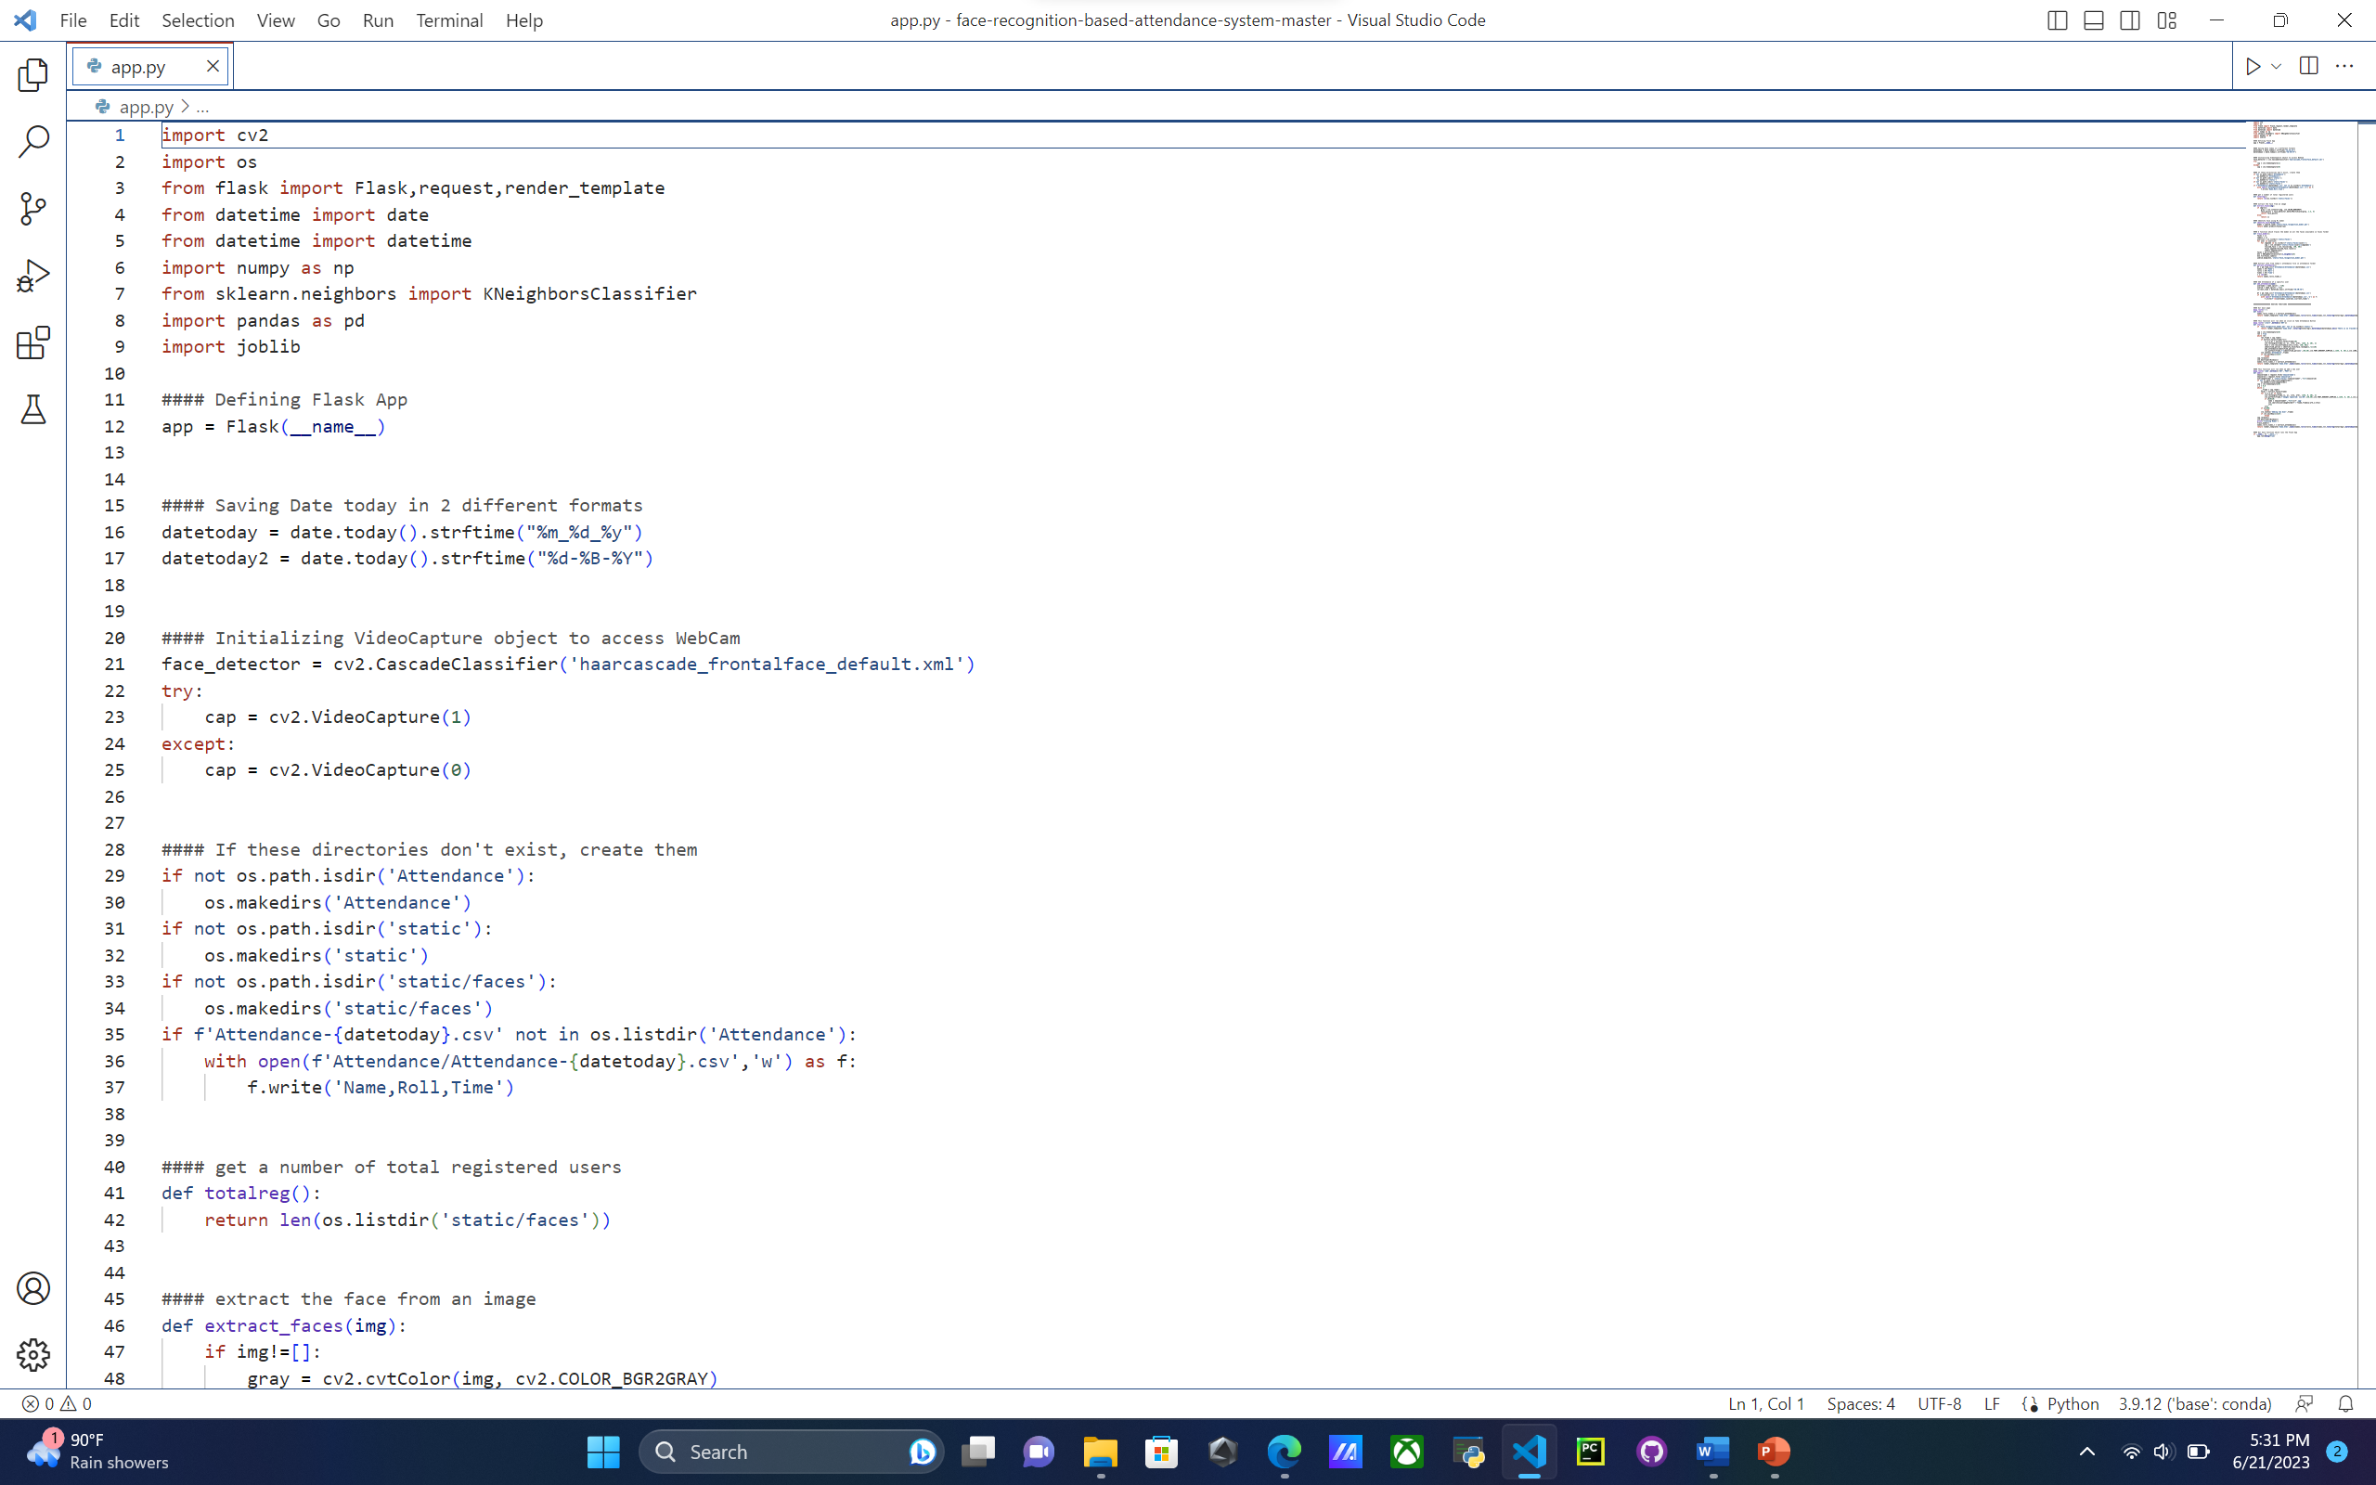

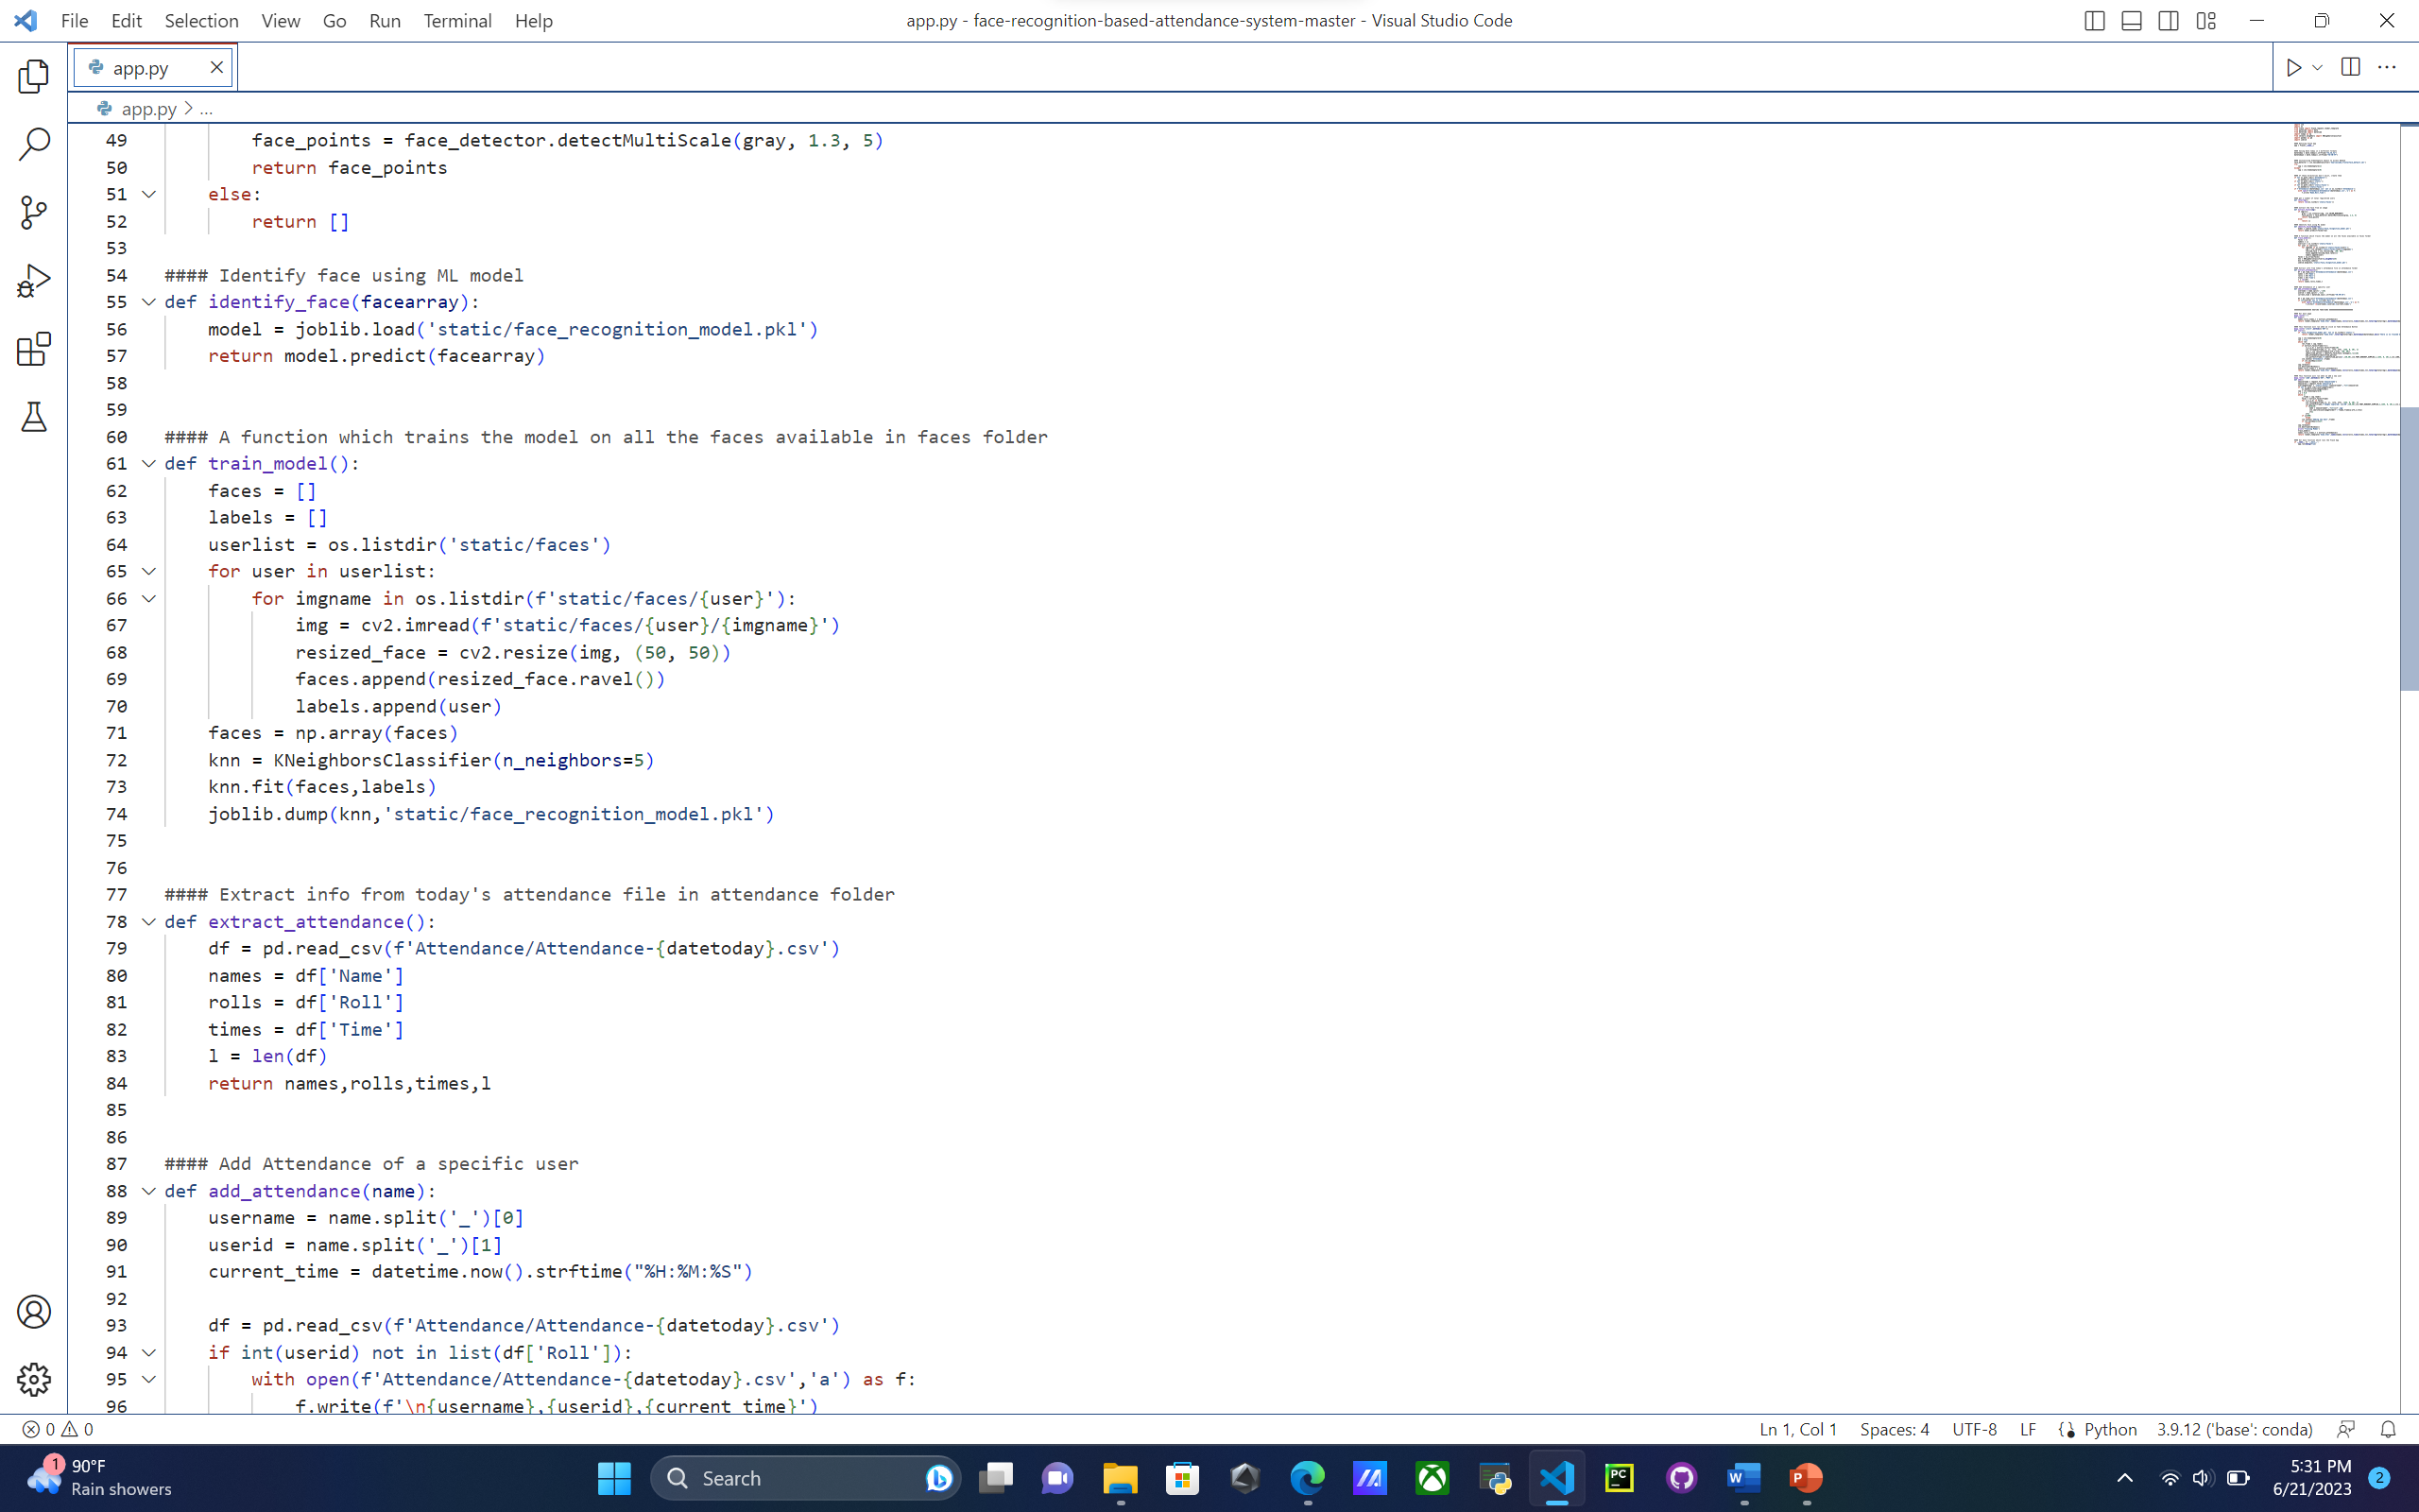

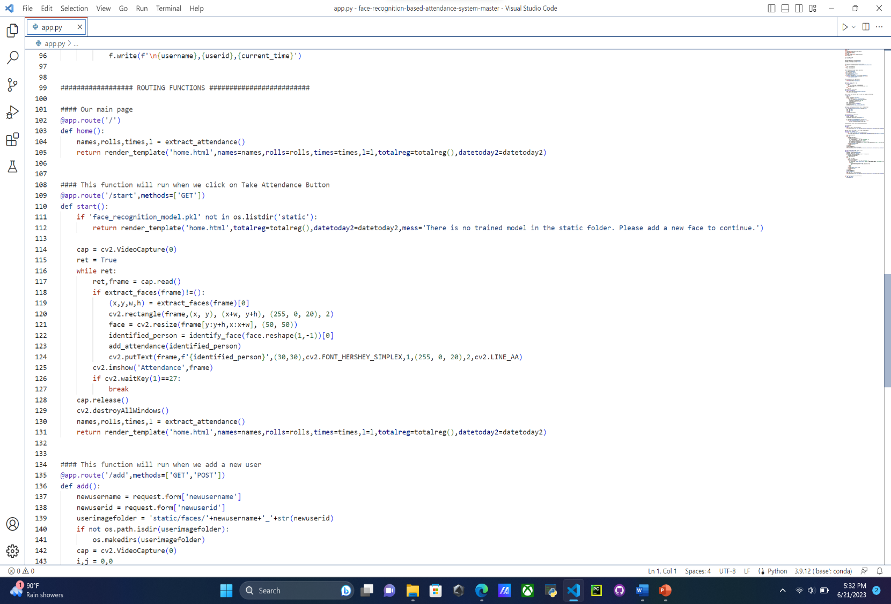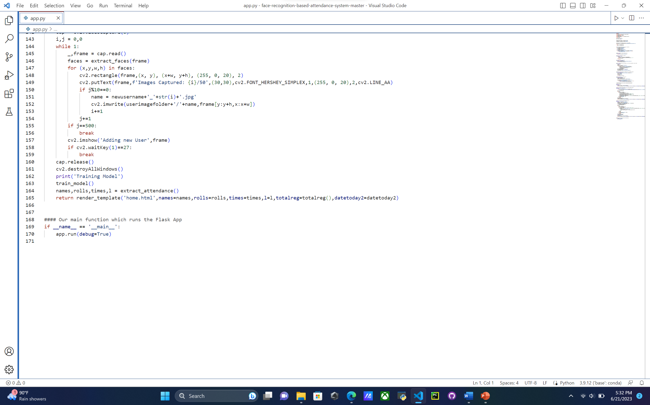

Home.html:

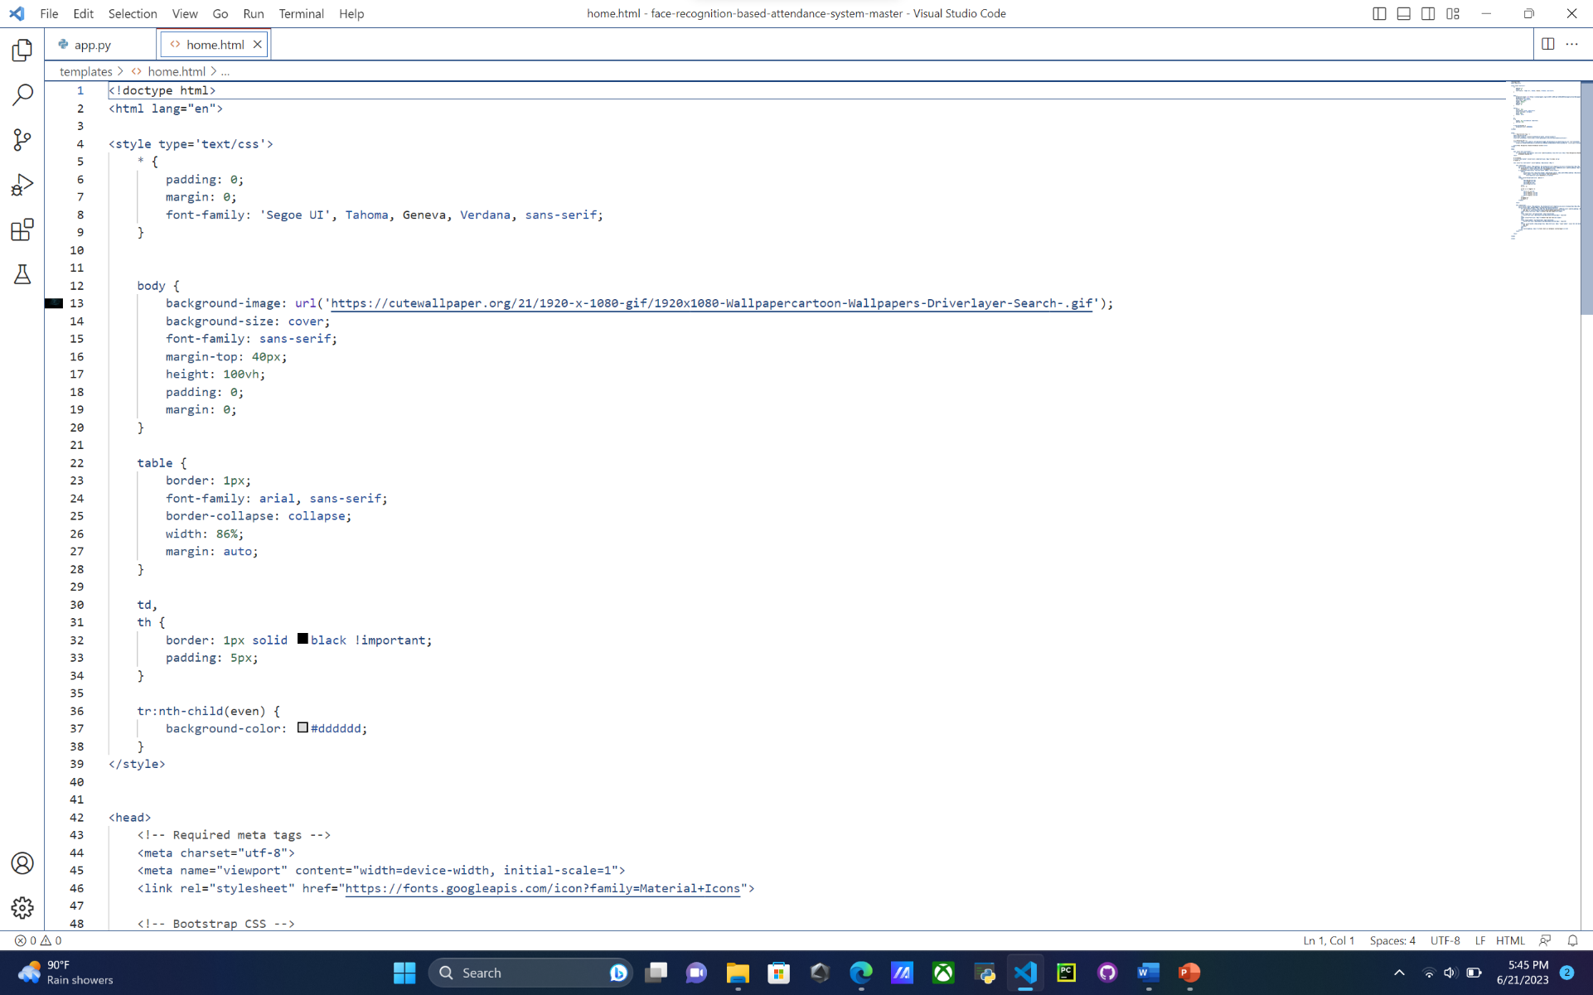

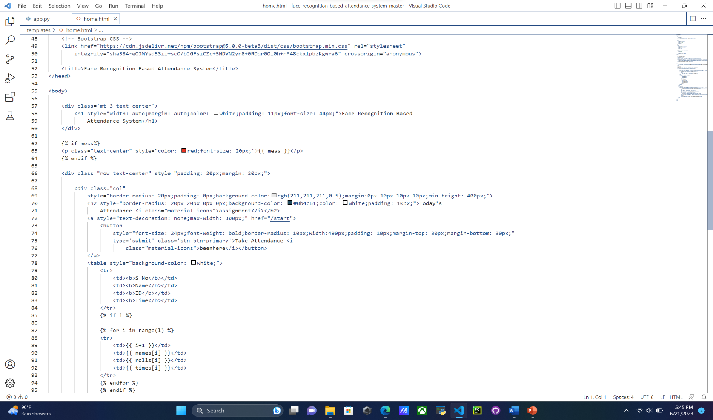

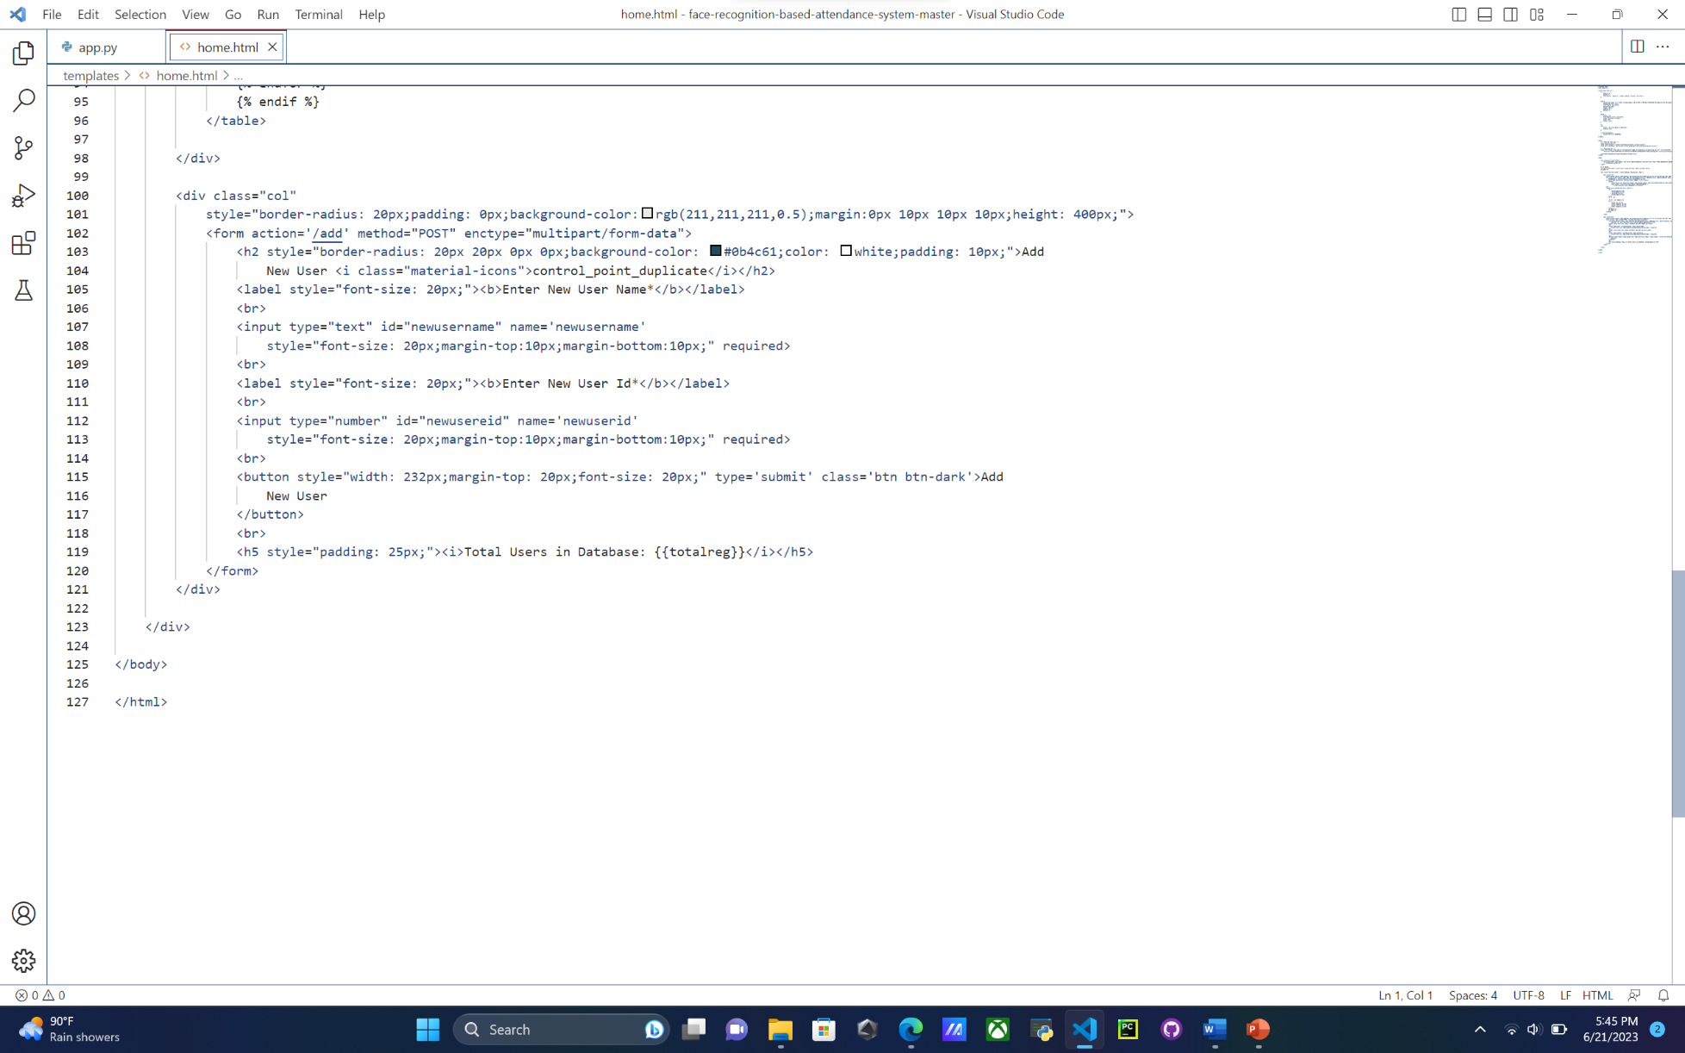

**CHAPTER-5**

**Results and Discussions**

**Main Screen**

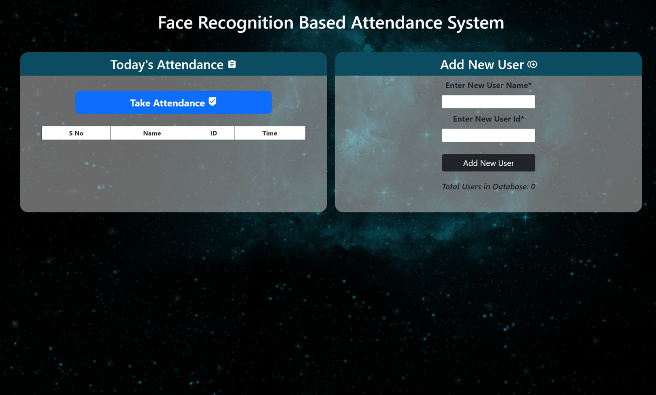

Step-1:Enter Username & ID

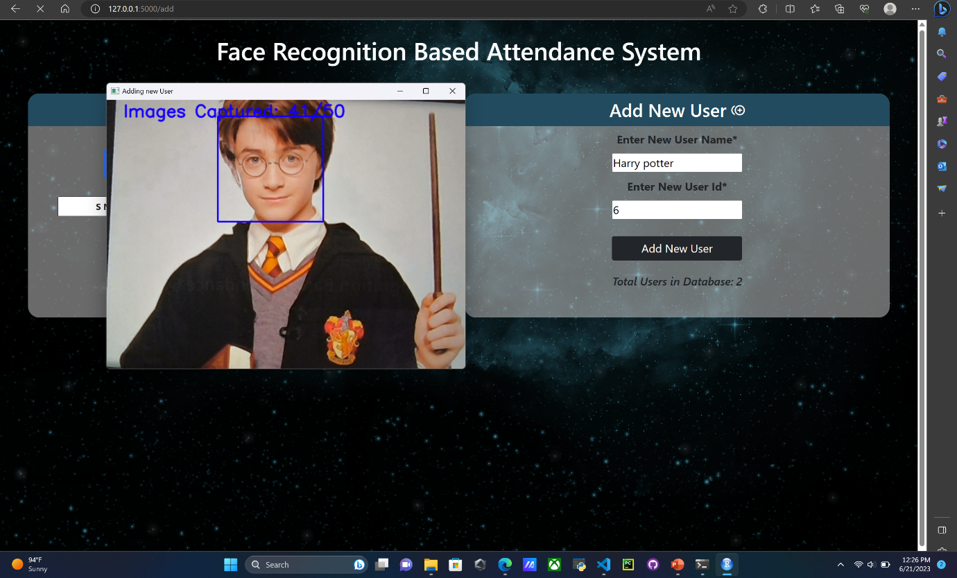

Step-2: Faces Captured in Static Folder

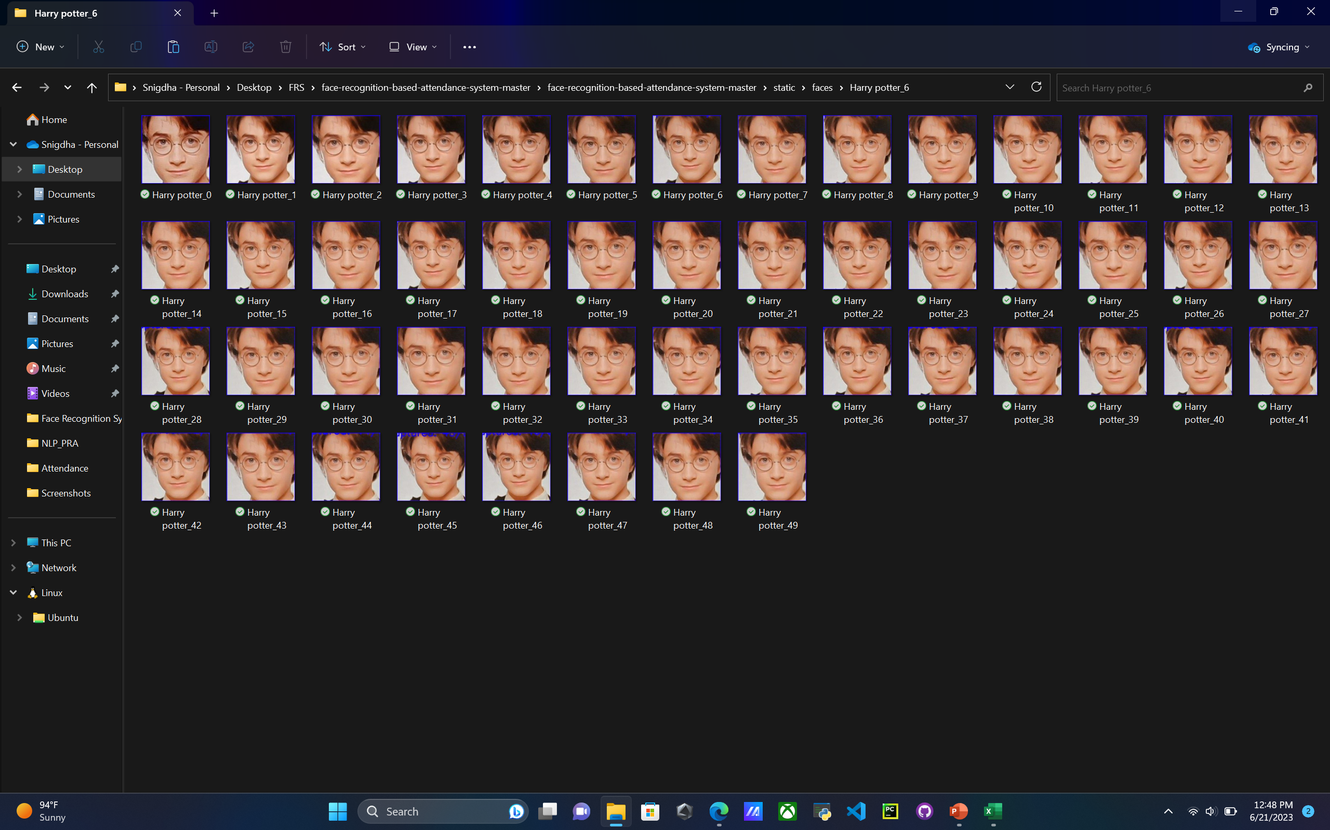

Step-3:Taking Attendance

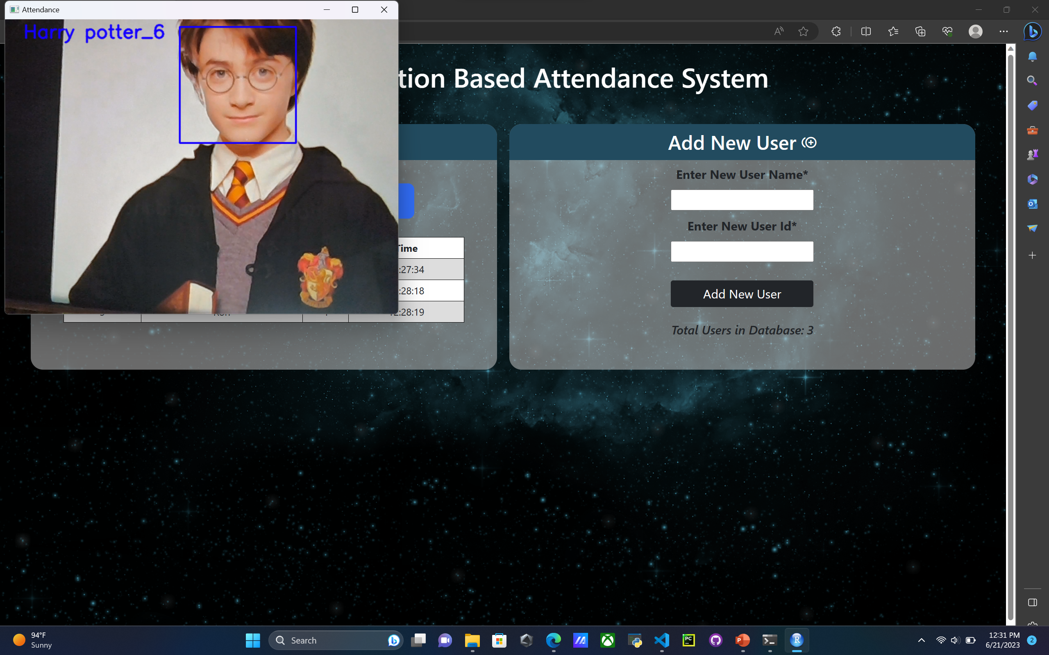

Step-4: Showing Attendance taken:

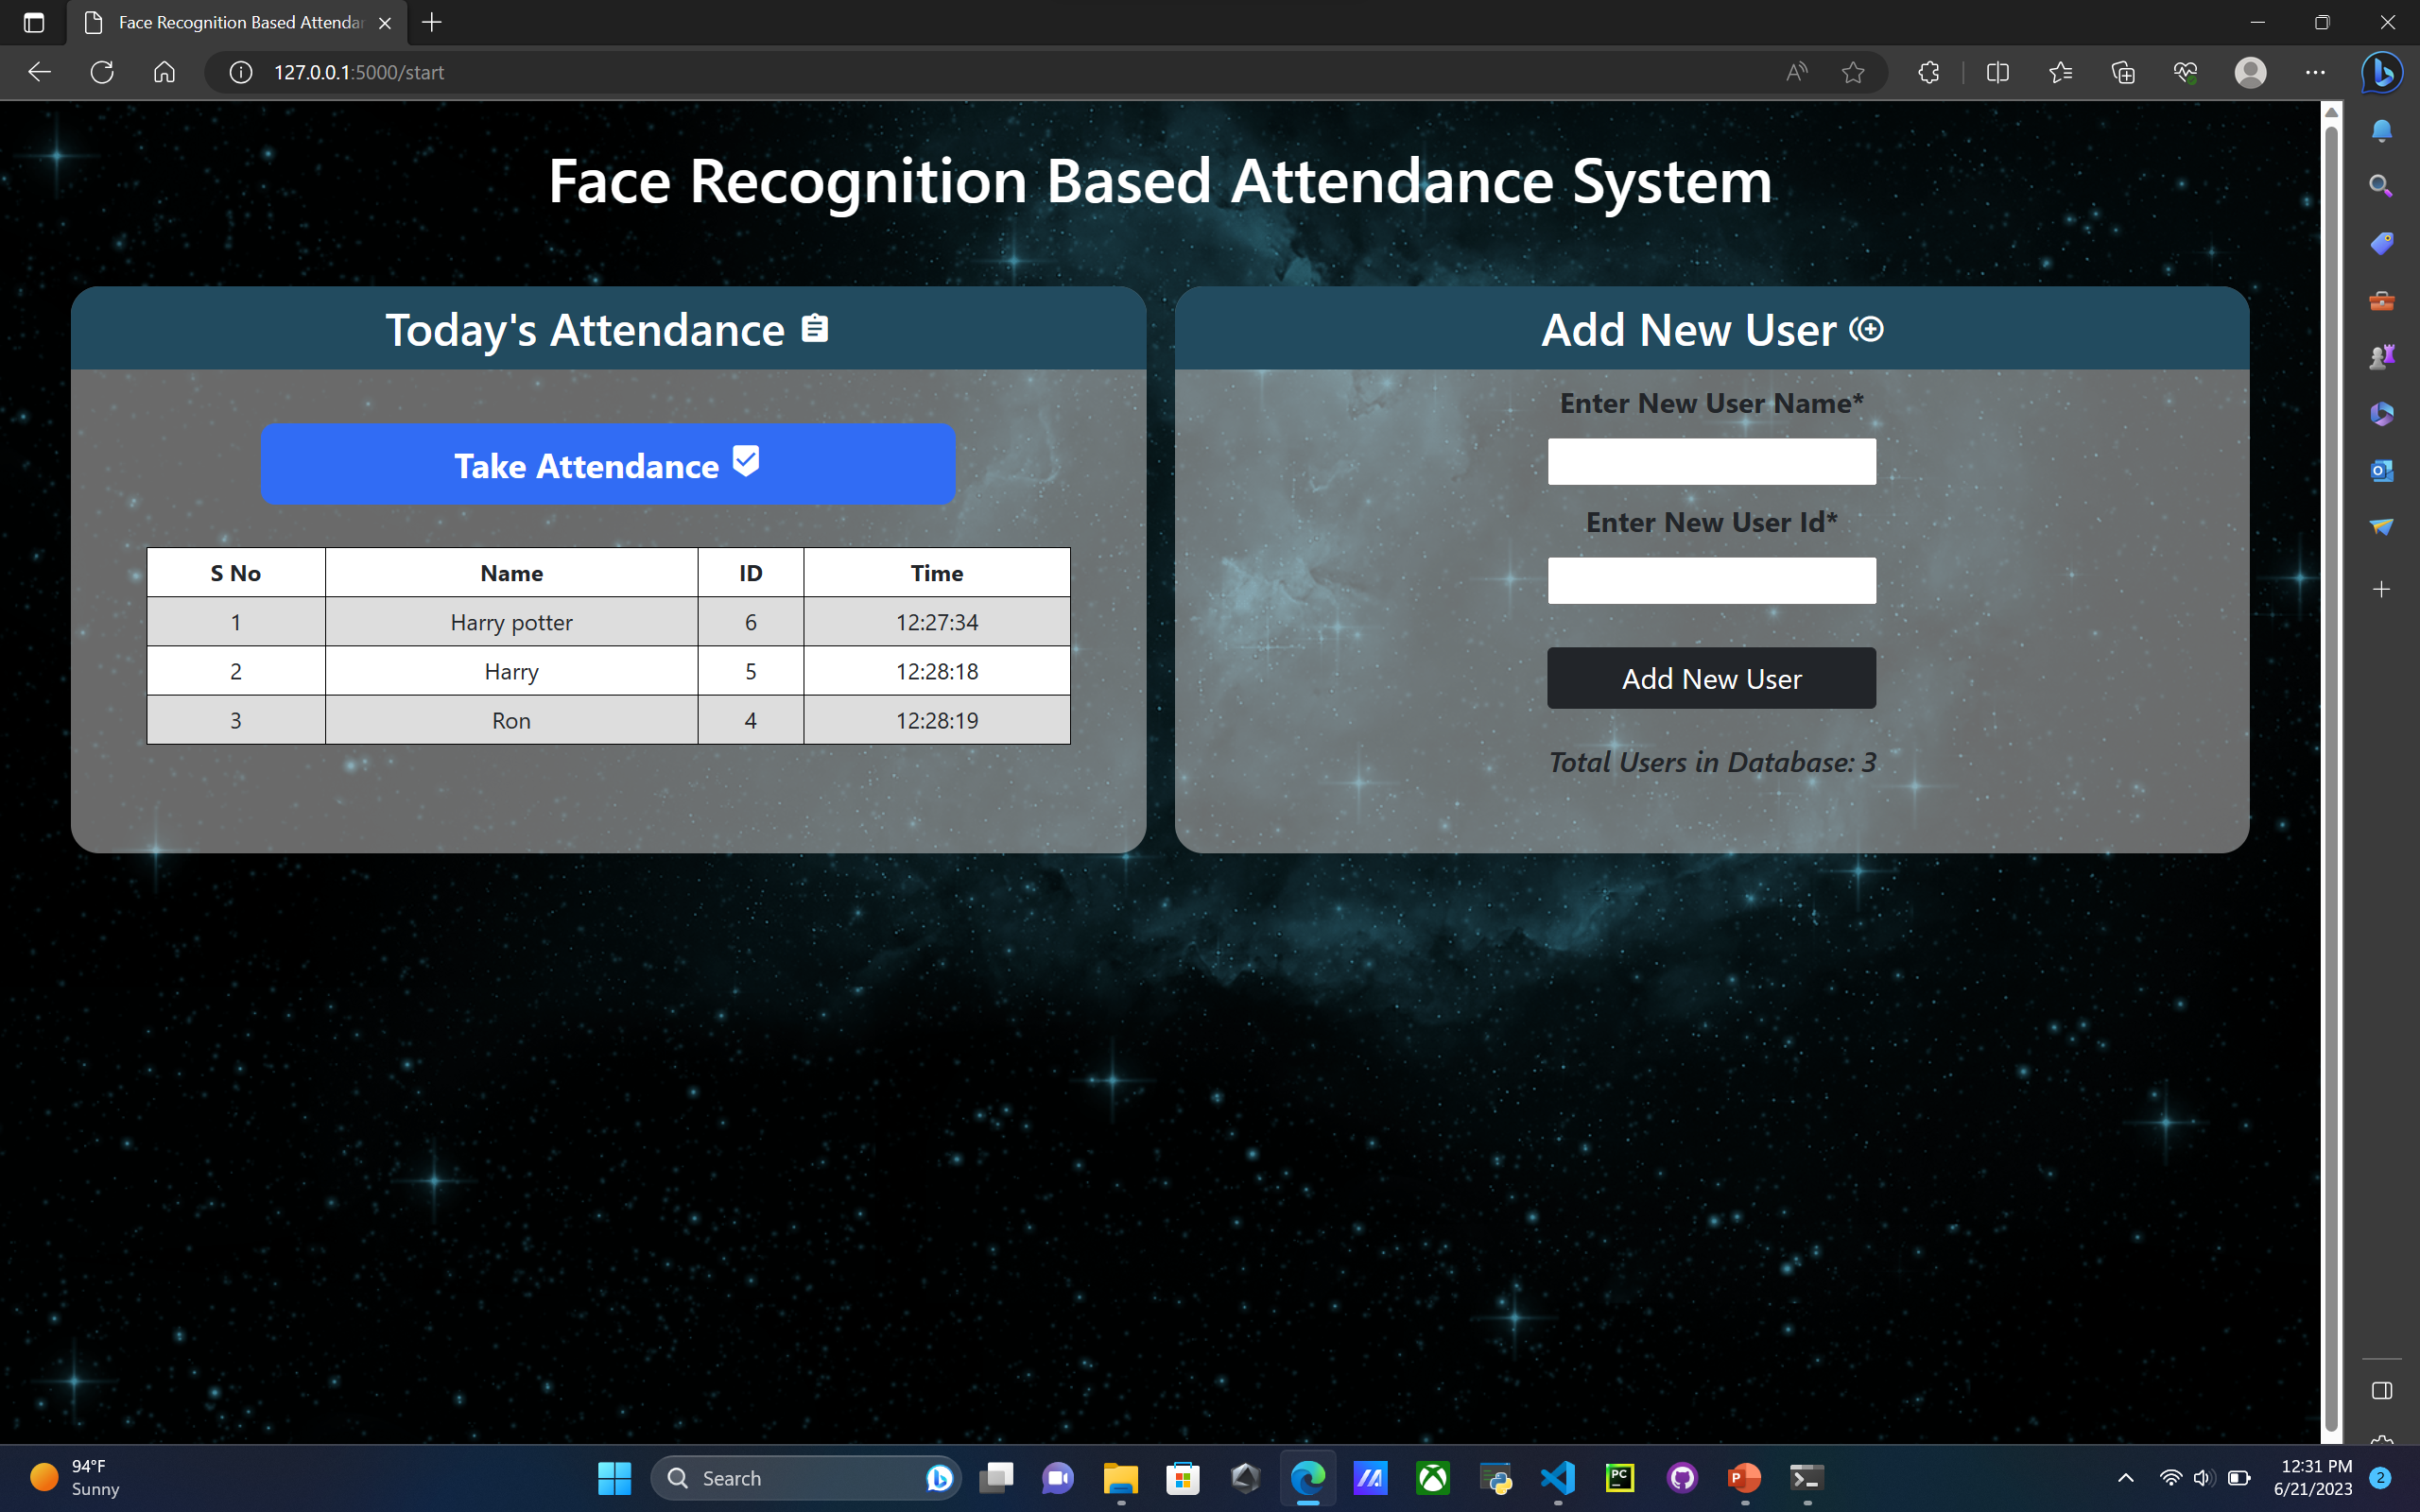

Step-5: Attendance Sheet



**CHAPTER-6**

**6.1 Conclusion**

We have implemented an attendance management system for student's attendance. It helps to reduce time and effort, especially in the case of large number of students marked attendance. The whole system is implemented in Python programming language. Facial recognition techniques used for the purpose of the student attendance. And also, this record of student attendance can further be used mainly in exam related issues like who are attending the exams and who are not attending.

On this project, there is some further works remained to do like installing the system in the class rooms. It can be constructed using a camera and computer.

Besides, we can simplify the system and make more efficient by taking advantage of multiple face detections to mark attendance of all the visible faces in single attempt. This will be economical and more efficient use of face recognition for attendance marking. We also consider to develop an android application for this system in near future.

* 1. **References**

[1] "A Survey on Face Recognition Techniques for Attendance Management Systems"

Authors: Smith, J., Johnson, A., Brown, C.

[2] "A Comprehensive Review on Automatic Attendance System Using Face Recognition"

Authors: Lee, S., Kim, H., Park, J.

[3] "Survey of Face Recognition Techniques for Attendance Management"

Authors: Sharma, A., Yadav, A., Kumari, M

[4] "Enhanced Face Recognition-Based Attendance System Using Machine Learning Techniques"

Authors: Singh, M., Kaur, R., Singh, K.

[5] B. Kavinmathi and S. Hemalatha, "Attendance System for Face Recognition using GSM module", *4th International Conference on Signal Processing and Integrated Networks”*, 2018.

[6] Kirtiraj Kadam, Manasi Jadhav, Shivam Mulay and Tushar Indalkar, "Attendance Monitoring System Using Image Processing and Machine Learning", *International Journal of Advance Engineering and Research Development*, 2017.

[7] Rajat Kumar Chauhan, Vivekanand Pandey and M Lokanath, "Smart Attendance System Using CNN", *International Journal of Pure and Applied Mathematics*, 2018.

[8] Salim, Omar Abdul Rhman, Rashidah Funke Olanrewaju, and Wasiu Adebayo Balogun. "Class attendance management system using face Recognition." 2018 7th International Conference on Computer and Communication Engineering (ICCCE). IEEE, 2018.

[9] Sunaryono D, Siswantoro J, Anggoro R (2021) An android based course attendance system using face recognition. J King Saud Univ Comput Inf Sci 33:304–312

[10] B Gornale, P. KiranClassroom Attendance Management System Using Camera International

Journal of Research in Engineering, Science and Management., 3 (8) (2020), pp. 327-330s

[11] "Privacy-Preserving Face Recognition-Based Attendance Systems: A Survey"

Authors: Li, W., Chen, J., Jiang, X.